The Role

Title: | Pastoral Support Worker
Contract: | Permanent
Hours: | 37 hours per week, term time only
Grade: | 7
Annual Salary: | £27,560 - £31,257 (FTE £32,061- £36,362) (depending on experience)
Start Date: | As soon as possible
Closing Date: | Midday Monday 12th January 2026
Interview Date: | Friday 16th January 2026

We are seeking a dedicated and enthusiastic Pastoral Support Worker to join a thriving team, supported by experienced colleagues, whose aim is to remove any barriers to learning and enable all students to access an outstanding education, through our varied curriculum.

USH is a heavily oversubscribed community school with just under 1100 students and 140 staff. We are incredibly proud of our family ethos and our success in delivering values-led education. Our students are vibrant, aspirational and well-behaved.
We are known for our excellent career progression routes and we attract professionals who are willing to contribute to our sustained success. USH is a Leading-Edge School, consistently ranked high in Hampshire schools for overall achievement. The school was delighted to be awarded SSAT accreditation for Transforming in Principled Curriculum Design in 2023.

If you are motivated to make a difference to the lives of young people and have a commitment to excellence, then this could be the job for you. Please do not hesitate to contact us if you have any questions about the role or would like to come into school to see the USH family in action.

The successful candidate will:
- Be highly motivated
- Be able to establish a rapport with adults and children
- Be able to demonstrate qualities of patience, firmness, humour and sensitivity
- Be steadfast in their belief and action, that the curriculum should be accessible for all
- Have experience of working with young people on raising their attainment and an understanding of the “barriers to learning”

What USH can offer you:-

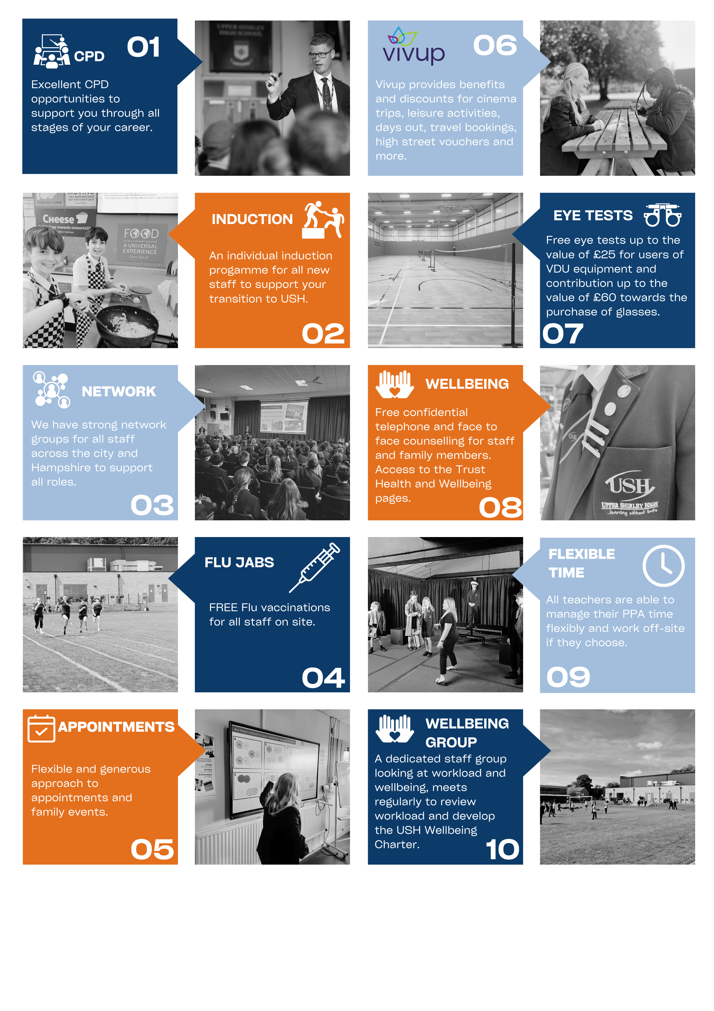

APPLICATION PROCEDURE
We positively encourage prospective candidates to enquire about our school prior to applying. Please contact our recruitment team via email: recruitment@ushschool.org

Full details and application forms can be downloaded from our website: http://uppershirleyhigh.org/staff_vacancies. Please return your completed applications to recruitment@ushschool.org.

To give your application the best chance at being short-listed, where at interview you can demonstrate suitability for the role, please ensure you read the person specification and job description and give examples in your application. Should you be new to the education sector or do not have direct examples related to the person specification, do please provide examples from a similar experience.

Please submit your application as soon as possible as we may invite candidates to interview before the closing date.

SAFEGUARDING
All schools within the Trust are committed to safeguarding and promoting the welfare of children and young people and expect all staff and volunteers to share this commitment.

We will ensure that all our recruitment and selection practices reflect this commitment. All successful candidates will be subject to Disclosure and Barring Service checks along with other relevant employment checks.

THE JEFFERYS EDUCATION PARTNERSHIP
The Jefferys Education Partnership is part of an umbrella Trust called the Hamwic Education Trust. At the Hamwic Education Trust we offer unique opportunities for those individuals that excel in education.

We aim to deliver an outstanding education to our pupils and to do so we must employ outstanding people.

We offer a training pathway for all employees including teachers, support staff and our middle and senior leaders.

Our staff have opportunities to work on cross phase projects and to work in other schools within the Trust in order to gain invaluable experience and enhance their skills.

Job Description

Title: | Pastoral Support Worker
Hours: | 37 hours per week, term time only
Grade: | 7
Responsible to: | Extended Leader Personal Development /Deputy Headteacher

Purpose of the job

To assist with the behaviour and welfare needs of pupils by providing first-line care and support.

To undertake a variety of administrative tasks to support the pastoral team.

Key accountabilities
Pastoral Support
- To communicate with pupils to assess social and emotional needs, behavioural difficulties and attendance and punctuality
- To work with children who require emotional care and support where appropriate; (in accordance with safeguarding training)
- Model and promote the Core Values of the school ensuring they permeate all aspects of the Year Teams
- To investigate student behaviour/welfare issues where they arise and to ensure there are effective outcomes
- To communicate with parents regarding any pastoral issues to arrange meetings in school and home visits to discuss pupil’s behaviour, attendance and punctuality
- To provide effective mentoring for individuals and small groups of students
- Liaison with external agencies where students have additional support
- To support the production of year group newsletters
- To produce individual reports on students for safeguarding or parent meetings
- Attending and making necessary preparations for Year Team meetings and taking appropriate follow up action
- To produce reports for the HOY or SLT on student behaviour and welfare when required
- Word processing of letters and documents as required
- Assist with arrangements for year group trips/projects
- Maintenance of year group display boards
- Attend pastoral meetings where appropriate
- As part of a wider team to supervise pastoral behaviour system sanction areas e.g. IE Room and Catch Ups
- Recognise and challenge any incidents of racism, bullying, harassment, victimisation and any form of abuse of equal opportunities, ensuring compliance with relevant school policies and procedures and making sure the individuals/s involved understand it is unacceptable
- Understand and implement school child protection procedures and comply with legal responsibilities
- Foster and maintain constructive and supportive relationships with parents/carers, exchanging appropriate information, facilitating their support for their child’s attendance, access and learning, and supporting home to school and community links
- Making judgements regarding when to refer students to external agencies for counselling or more specialised intervention as appropriate
- Any other duties within the responsibility level of this post, as directed by the Head of Year
Student Behaviour, Attendance and Punctuality
- To provide Heads of Year with timely reports and information on student achievement points
- To support Heads of Year with the administration of the achievement point system including the publication of certificates
- To support the pastoral team with the administration of attendance, punctuality and uniform sanctions
- To attend attendance meetings with the Attendance Officer when required
- To act on information provided by/work in collaboration with the Attendance Officer, providing ‘same day’ follow-up telephone calls notifying parents/carers and securing the reason(s) for pupils’ non-attendance or poor punctuality
- To ensure students attend attendance, punctuality and uniform detentions and to take actions alongside the Year Team where this is not the case
- To maintain appropriate Pupil Behaviour Records
- To make full use of the capability of the Bromcom pupil information system (behaviour, attendance, mentoring, and assessment data)
- To analyse records of pupil behaviour and utilising results effectively
- To track behaviour data and intervene with students to support improvements in behaviour
- To monitor potential internal truancy and support students in attending all lessons
- To communicate regularly with Heads of Year and Assistant Heads of Year to ensure appropriate interventions are in place for students failing to adhere to the behaviour systems
- Organising and overseeing Internal Exclusions

Teaching and Learning
- Promote and support the inclusion of all pupils, including those with specific needs, both in learning activities
- Promote and reinforce children’s self-esteem and independence and employ strategies to recognise and reward achievement of self-reliance

Administration
- To undertake the typing / word-processing, collation and distribution of correspondence, reports, minutes and other documents as required;
- To undertake administrative duties including record keeping, ordering, photocopying, filing, and dealing with incoming and outgoing mail;
- To use computer systems (e.g. MIS, CPOMs, Provision Maps) to input details, analyse and interpret data, run reports and make returns as required;
- Under direction of the Head of Year, to liaise with other school staff, school associations and outside agencies/organisations as appropriate;
- Maintaining accurate records of pupil behaviour, attendance and punctuality and analysing this information to coordinate the appropriate award of rewards.
- Preparing drafts on written communications with parents and outside agencies

SUPPORTING THE SCHOOL
At an appropriate level, according to the job role, grade and training received, all employees in the school are expected to:
- Support the aims, values, mission and ethos of the school and participate in a team approach to all aspects of school life
- Attend and contribute to staff meetings and INSET days as required, and identify areas of personal practice and experience to develop
- Take appropriate responsibility for safeguarding and children’s welfare and be aware of confidential issues linked to home/child/teacher/school and keep confidences appropriately
- Be aware of health and safety issues and act in accordance with the school’s Health and Safety Policy
OTHER DUTIES
The postholder may be expected to carry out duties other than those given in the job description where the level of responsibility is similar and he/she has appropriate qualifications or receives appropriate training to carry out these duties.
The postholder must:
- Ensure that trust policies and procedures are implemented and followed;
- Work as appropriate with the Trust Central Services team in matters relating to finance, HR, IT and Health and Safety

Person Specification

Title: | Pastoral Support Worker
Grade: | 7

Skills/ ability/ experience | To do what? | How well?  Now or with training? | How important at the time of appointment?
Knowledge & Understanding:
English and Maths to GCSE Grade C or equivalent together with a relevant qualification at NVQ Level 3 or equivalent | To demonstrate a good level of numeracy and literacy | Now | 5
Previous experience of working with children with social, emotional and behavioural difficulties, and with their parents | To understand, support and engage the children  To form good, positive working relationships with the parents | Now | 5
Some experience in the support of the emotional literacy of students and the use of restorative practice techniques. | To understand students’ barriers to learning and enable them to overcome these | Now | 5
Mental Skills:
Ability to plan in short/medium term | To plan work activities for groups of children who may display a variety of behavioural difficulties  To organise support events/activities for parents | Now | 5
Interpersonal & Communication Skills:
Ability to communicate effectively to a range of audiences, through excellent written and oral communication skills | To establish positive and respectful relationships with pupils and parents, to enable effective support, advice and counselling to be provided  To develop and maintain effective working relationships with colleagues and outside agencies/organisations | Now | 5
Initiative & Independence:
Ability to work on own initiative and to organise/prioritise own workload | To work independently and to make decisions on day to day issues without recourse to senior management | Now | 4
Mental Demands:
Ability to concentrate on detailed work for prolonged periods of time | To analyse data, produce reports, concentrate in meetings etc | Now | 5
Emotional Demands:
Ability to work with, support, understand and empathise with children who may have a complex range of emotional, behavioural and physical needs | To work with individuals or groups of children who are experiencing social, emotional and/or behavioural difficulties and to establish relationships with their parents | Ability/  aptitude essential now. Training given in specific procedures | 5
Ability to remain calm when working with students, utilising the tools and techniques of restorative practice (RP) | To listen to children, establish relationships and (in accordance with school policies and procedures) be able to act/deal appropriately with emotionally difficult situations | Ability/  aptitude essential now. Training given in specific procedures | 5
Responsibility For People:
Understanding of key safeguarding issues and procedures | To ensure correct reporting and monitoring of any safeguarding issues arising across the school  To maintain appropriate levels of confidentiality and data security in respect of personal / pupil / colleague information | Awareness of the sensitivity of these issues now. Training in school procedures given | 5
Responsibility For Physical Resources:
Ability/experience in using office computer systems (e.g. MS Word, Excel etc) and school computer systems (Bromcom) | To produce documentation, interrogate systems and analyse data | IT skills now. Specific training will be given in school systems if required | 4

