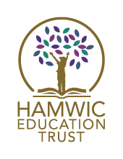
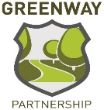

ADVERT

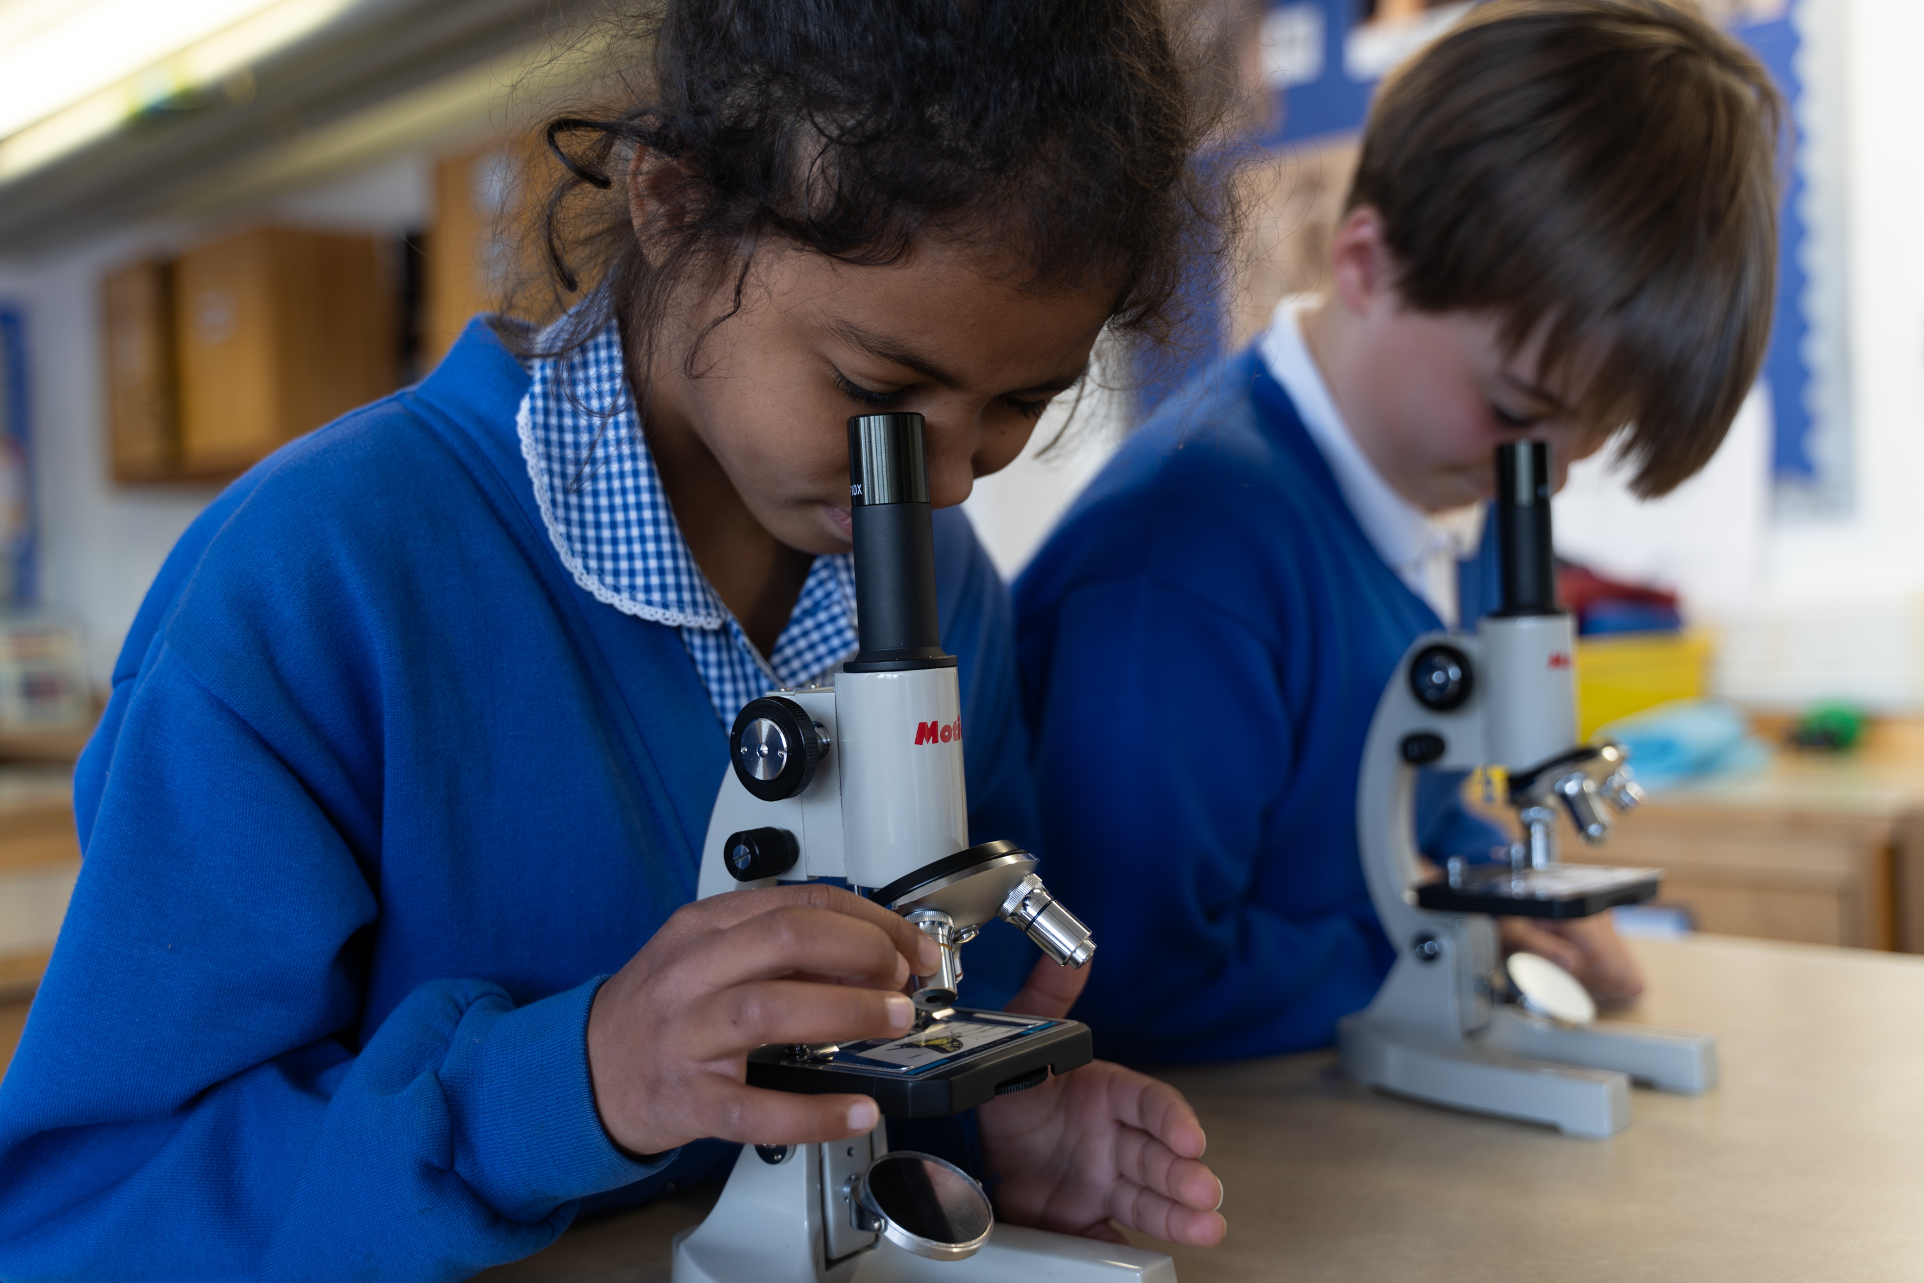


ROLE: 1:1 Teaching Assistant (Fixed term until 31 August 2026)
SCHOOL: Talbot Primary School
HOURS: Part time (19.5 hours per week)
SALARY: Grade C - SCP 3 £22,737 FTE (actual salary £17,101.78)
Grade D - SCP 5 £23,500 FTE (actual salary £17,675.68)
Salary offered will be dependent on experience
CLOSING DATE: Sunday 28 February 2026
INTERVIEW DATE: Wednesday 4 March 2026
START DATE: As soon as possible

We have an exciting opportunity to recruit an enthusiastic, highly skilled and inspiring Teaching Assistant to work 1:1 with children at the school. This is a fixed term contract until the end of the academic year.

HET is a large, fast-paced Trust with currently 37 academies across the South Coast. Linked to 6 community-based partnerships, there are 33 primary academies, 2 secondary and 1 hospital school.

Teaching Assistants with advanced levels of experience and practice in school are encouraged to apply. Training to support you in your role is offered.
We welcome applications from graduates looking for a route towards a career in teaching.

Talbot Primary is an ambitious, friendly and happy school for children aged 4 to 11 years. Recently graded ‘Good’ by Ofsted (January 2022), we are looking for an inspirational, enthusiastic and creative Teaching Assistant to join our team. Wellbeing is at the heart of our leadership, and we strive for quality teaching and a healthy work/life balance.

We offer our pupils an enriched curriculum, striving for high academic standards across the whole curriculum to give every child the opportunity to achieve their full potential. To fulfil this ambition, we nurture the “whole” child and encourage their emotional and social development as well as their learning attainment.

Our school is the heart of its community; our vision where children thrive and achieve is embedded in all that we do for our pupils and the wider community. We are a safe and happy school committed to ensuring that all our children have the best possible education during this vital time of their lives. We provide education for Reception children (Age 4) to Year 6 (Age 11), situated on the beautiful South Coast. We are located in an urban setting in extensive playing fields and grounds, which includes a beautiful indoor swimming pool, Forest School and a large, productive garden, which is used to grow fruit, vegetables and sensory planting.

Visits to the school prior to interview are strongly encouraged, please contact the school on 01202 513981 to arrange a school visit.

HAMWIC EDUCATION TRUST (HET):

HET is a large, fast-paced Trust with currently 37 academies across the South Coast. Linked to 6 community-based partnerships, there are 34 primary academies, 2 secondary and 1 hospital school.

‘All about the Child’
At HET, we aim to put the child at the centre of everything we do. We believe that by doing this, it drives our ethos and values to do the best we can for our children.

‘What about Sam’
Sam is the name we have given to the notional Hamwic child. By asking ourselves, ‘What about Sam?’ we ensure that we put our pupils at the heart of our decision making.

WE ARE SEEKING:
- Ideally an NVQ Level 2 Teaching Assistant or equivalent certificates in Childcare and Education, or the commitment to enrol on the NVQ Level 2 Teaching Assistant apprenticeship.
- GCSEs Grade 4 or C or above in English and Maths.
- Experience of supporting Primary aged children’s learning within the classroom across all age groups.
- An understanding of children with health care needs.
- A good understanding of behaviour management strategies.
- Be a great team player.

WE CAN OFFER YOU:
- Excellent CPD opportunities and Training and Development Programmes
- In-house Teaching School
- An individual induction programme supported by a mentor
- Eligibility to join the Local Government Pension Scheme
- Free eye tests up to the value of £25 for users of VDU equipment and contribution up to the value of £60 towards the purchase of glasses specifically for the use of display screen equipment (where all conditions are met)
- Opportunity to become a school workplace Health and Wellbeing representative, meeting with other schools on a termly basis and feeding into the Health and Wellbeing strategy
- Access to the Trust Health and Wellbeing pages
- Access to a staff benefits portal through Vivup
- Free confidential telephone and face to face counselling for staff and family members

APPLICATION PROCEDURE:
Should you wish to apply for this vacancy, please view the job description and complete the application form and return to the HR Officer at hr@talbot.poole.sch.uk.

SAFEGUARDING:
All schools with the Trust are committed to safeguarding and promoting the welfare of children and young people and expect all staff and volunteers to share this commitment.
We will ensure that all our recruitment and selection practices reflect this commitment. All successful candidates will be subject to Disclosure and Barring Service checks along with other relevant employment checks.

THE GREENWAY PARTNERSHIP
The Greenway Partnership is part of an umbrella Trust called the Hamwic Education Trust. At the Hamwic Education Trust we offer unique opportunities for those individuals that excel in education.
We aim to deliver an outstanding education to our pupils and to do so we must employ outstanding people.
We offer a training pathway for all employees including teachers, support staff and our middle and senior leaders.
Our staff have opportunities to work on cross phase projects and to work in other schools within the Trust in order to gain invaluable experience and enhance their skills.

