
Class Teacher (1 year fixed term)
Lytchett Matravers Primary School


Location: | Lytchett Matravers Primary School
Contract: | Full Time – Fixed Term until 31st August 2027
Salary: | M1-M6 / UPS1–UPS3 – ECT applicants welcome
Application deadline: | Friday 20th March 2026
Interview date: | W/C 23rd March 2026
Start Date: | September 2027



Our school has been at the heart of our village community for the last 150 years. We understand how important it is that children feel that they belong with us and that they are developed to become the best that they possibly can be. Through our care and cooperation with parents / carers and other stakeholders, we support all children to ‘Thrive Together’: our school motto.

Our school consists of Lytchett Matravers Preschool and our main primary school: the buildings sit adjacent to each other on the same site. All learning spaces are purpose built and resourced to allow for appropriate development relative to the children’s stages of learning. The main school has two classes per year group, with children admitted from aged 4-11 (Reception Year – Year 6).

We are extremely fortunate with our outdoor space. Preschool have multiple outdoor learning areas, including a bespoke space for physical development activities, a garden area, a mud kitchen and access to the forest school site. The school site also includes a large field, an orchard, a small woodland and direct access to a Multi-Use Sports Area.

Our school is part of the Hamwic Education Trust – a Multi Academy Trust based on the South Coast. We also belong to a group of ‘Pyramid’ schools that feed into our local secondary, Lytchett Minster School, as well as a collective of 7 schools that form the ‘Hillary Partnership’. Collaboration across these provisions enhances our practice and furthers the support that we are able to offer to our children.

Our school is situated in a rural village location in the heart of Dorset. We retain all of the benefits of being in the countryside whilst still being close to Bournemouth and Poole: Poole Harbour is 5 miles from the school. We are also close to a range of attractions such as Corfe Castle, Brownsea Island and the beauty of the Jurassic coast.
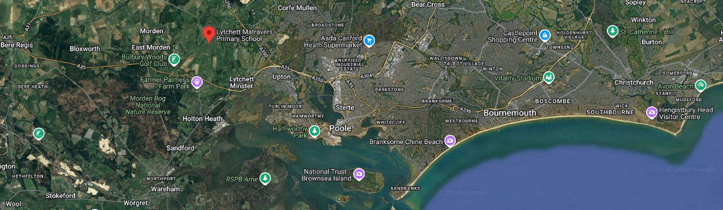

Role Summary:

We are seeking to appoint a committed, enthusiastic and outstanding teacher for the 26/27 academic year. We offer a supportive team of experienced teachers who work collaboratively in the best interests of the children. We welcome applications from ECTs and can provide access to a comprehensive training package for those at the start of their teaching careers.

We are seeking a professional individual who is:

- An excellent classroom practitioner
- Able to create a stimulating and inclusive environment for all pupils
- Enthusiastic, imaginative and creative
- Skilled at building good relationships with parents and staff
- Committed to raising standards and achievement in all areas of school life
- Be willing to undertake CPD to develop your understanding and knowledge
- Willing to support after-school learning opportunities

We welcome visits to the school – do get in touch with us should you wish to arrange a tour or if you have any questions about the position.

What we offer you:

- An opportunity to be part of a collaborative team with a shared vision of excellence
- A real career path in a thriving and respected organisation
- Flexible working approach, where possible
- Wellbeing day (trial for 2025/26)
- Excellent training and development programmes and opportunities
- Eligibility to join the Local Government Pension Scheme / Teacher Pension Scheme
- Access to our benefits portal offering a full range of discounts available through Lifestyle Savings
- Access to wellbeing support through our Employee Assistance Programme, this includes free confidential telephone and face to face counselling for employees and family members
- Access to financial wellbeing support through a company that provides comprehensive guidance on all things mortgage related
- Eligibility for a Blue Light card

About Hamwic Education Trust:

HET is fully committed to developing an outstanding workforce. We are a friendly and supportive community of professionals working hard to ensure that our schools are enabling children to grow and develop for the future.

We have talented staff working in leadership, teaching and support roles throughout our schools and committed professionals working in the Managed Services team covering education, safeguarding, HR, IT, finance and estates. This experienced team supports our schools and is responsible for the successful delivery of our multi-academy trust.

As an employer, we support our staff to grow through continuing professional development and there is a range of apprenticeships and other opportunities available throughout the Trust to extend your knowledge, skills and career prospects.

HET celebrates the uniqueness of our pupils, our staff and our schools and we aim for everyone to achieve their full potential through the pathways of opportunities available.

HET recognises that by valuing and promoting equal opportunities in employment for all employees and job applicants and avoiding unlawful discrimination in employment and delivery of services, we will be able to deliver first class education and value the differences our workforce brings to HET.

Application Procedure:

If you would like to discuss the role further, please contact Peter Leddin by emailing operationsmanager@lmpsdorset.co.uk to arrange an informal chat or have a tour of the school. Potential candidates will be asked to bring their current school ID and/or photographic ID as proof when they visit the school for a tour.

If you wish to apply for this position, please complete an application form which can be found at
Job vacancies | Careers | Hamwic Education Trust | Multi-academy Trust and return to operationsmanager@lmpsdorset.co.uk. Application forms can also be requested via this e-mail address.

CV’s will only be accepted along with a completed application form.

Please note, we may close the advert prior to the advertised closing date should we have sufficient applications. We strongly encourage prospective applicants to apply as soon as possible.

Hamwic Education Trust (HET) are committed to safeguarding and protecting the welfare of our pupils and we expect all staff and volunteers to share this commitment.

All posts are subject to a safer recruitment process which includes enhanced criminal record and barring checks, scrutiny of work and training history, robust referencing, and other vetting checks. Successful candidates will also be subject to online searches.

Our safeguarding system is underpinned by a range of policies and procedures which encourage and promote safe working practice across HET.

All HET employees are required to undergo continuous professional development to maintain safe working practices and to safeguard our pupils.

