

Teacher
Role Profile
Grade: Main Pay Scale / Upper Pay Scale

Accountable to: Head Teacher

Place of Work: Lytchett Matravers Primary School

Hours: Full time

Role Remit:
The teacher will:
- Fulfil the professional responsibilities of a teacher, as set out in the School Teachers’ Pay and Conditions Document
- Meet the expectations set out in the Teachers’ Standards (see link Teachers’ Standards guidance)
- Meet the expectations set out in the HET Standards for Teachers & School Leaders as part of the Professional Development policy.

Relationships:
- Teachers are accountable to their line manager in all matters.
- Within the Professional Development process, all teachers in the school are accountable to the School Leader through their respective teams and leaders.
- Within the learning management process, all teachers are accountable for the profiles and performance of all pupils they teach.
- Within continuing professional development (CPD) all teachers are accountable for the impact their development has on pedagogy.
- Teachers make the education of their pupils their first concern and are accountable for achieving the highest possible standards in work and conduct. Teachers act with honesty and integrity; have strong subject knowledge, keep their knowledge and skills as teachers up-to-date and are self-critical; forge positive professional relationships; and work with parents in the best interests of their pupils.

Main Responsibilities:
- Teaching:
- Plan and teach well-structured lessons to assigned classes, following the school’s plans, curriculum and schemes of work
- Assess, monitor, record and report on the learning needs, progress and achievements of assigned pupils, making accurate and productive use of assessment
- Adapt teaching to respond to the strengths and needs of pupils
- Set high expectations which inspire, motivate and challenge pupils
- Promote good progress and outcomes by pupils

- Demonstrate good subject and curriculum knowledge
- Participate in arrangements for preparing pupils for external tests

- Whole school organisation, strategy and development:
- Contribute to the development, implementation and evaluation of the school’s policies, practices and procedures, so as to support the school’s vision and values
- Make a positive contribution to the wider life and ethos of the school

- Work with others on curriculum and pupil development to secure co-ordinated outcomes
- Provide cover, in the unforeseen circumstance that another teacher is unable to teach

- Health, safety and discipline:
- Promote the safety and wellbeing of pupils
- Maintain good order and discipline among pupils, managing behaviour effectively to ensure a good and safe learning environment

- Professional development:
- Take part in the school’s professional development process
- Take part in further training and development in order to improve own teaching and practice
- Take part in the professional development of others, where appropriate

- Communication:
- Communicate effectively with colleagues, pupils, parents and carers
- Communicate effectively with wider school community and HET managed services team

- Working with colleagues and other relevant professionals:
- Collaborate and work with colleagues and other relevant professionals within and beyond the school
- Develop effective professional relationships with colleagues

- Personal and professional conduct:
- Uphold public trust in the profession and maintain high standards of ethics and behaviour, within and outside school
- Have proper and professional regard for the ethos, policies and practices of the school, and maintain high standards of attendance and punctuality
- Understand and act within the statutory frameworks setting out the professional duties and responsibilities of a teacher

- Safeguarding:
- Work in line with statutory safeguarding guidance (e.g. Keeping Children Safe in Education, Prevent) and the school’s safeguarding and child protection policies
- Work with the designated safeguarding lead (DSL) to promote the best interests of pupils, including sharing concerns where necessary

- Promote the safeguarding of all pupils in the school

- Management of employees and resources (if applicable):
- Direct and supervise support staff assigned to the teacher, and where appropriate, other teachers
- Contribute to the recruitment and professional development of other teachers and support staff
- Deploy resources delegated to the teacher

Other Duties:
At an appropriate level, according to the job role, grade and training received, all employees in HET are expected to:
- Support the vision, ethos and strategic aims of HET and participate to the one team approach, All About the Child and What About Sam?
- Attend and contribute to staff meetings and training days as required and identify areas of personal practice and experience to develop.
- Take appropriate responsibility for safeguarding and children’s welfare and be aware of confidential issues linked to home/child/teacher/school and keep confidences appropriately.
- Have read and understood all relevant HET and school policies and procedures, including HET whistleblowing policy.
- The post holder at all times, whether or not in the employ of our schools or HET and except where such information is in the public domain maintain the strictest secrecy with regard to the business affairs of our schools or HET and its customers/stakeholders, products and product lists.
- Be aware of health and safety issues and act in accordance with the Health and Safety Policy.
- To liaise with other HET employees, contractors and outside agencies/organisations as appropriate.

This job description may be amended at any time in consultation with the postholder.

School Leader Signature: ...…………………………………………………………………………………

Employee Signature: …….….…………...…………………………………………………………….

Date: ………………………….…………………………………………………………

Teacher
Person Specification

HET have identified the traits below that they feel every employee should have.

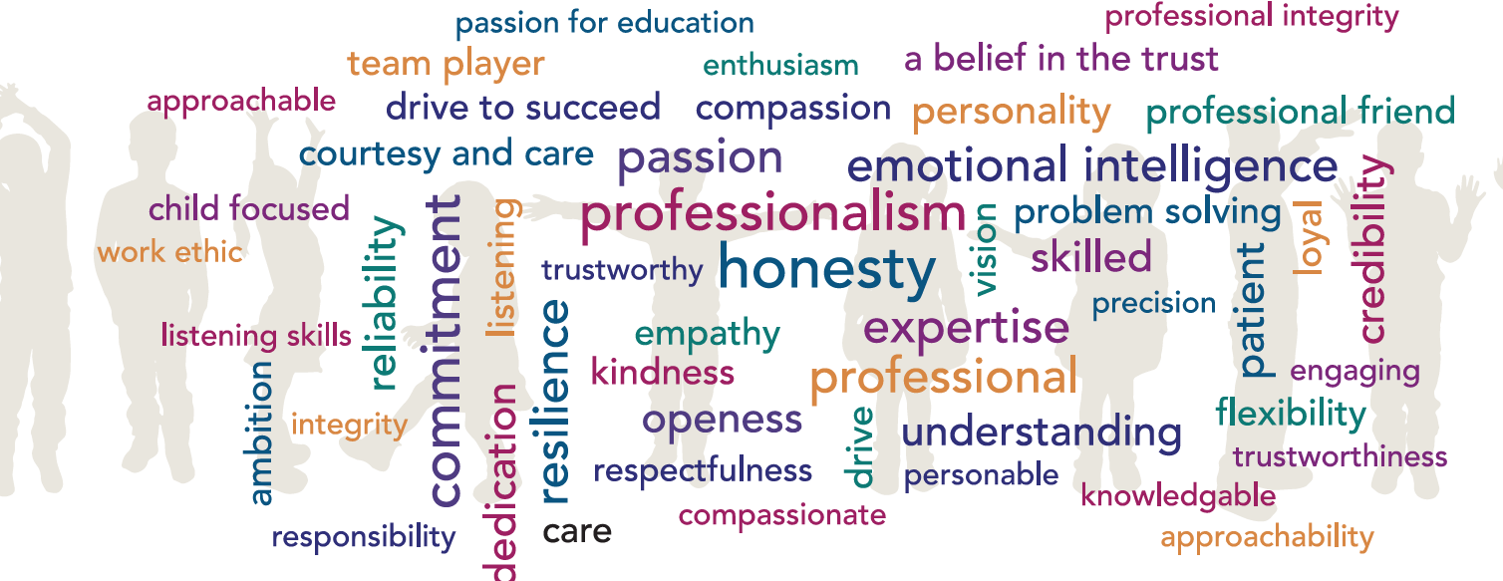

CRITERIA/STANDARD | Essential (E) / Desirable (D) | Measures:  Application form (A), interview (I)
QUALIFICATIONS

GCSE’s 9-4 / A*-C including maths and English | E | A
Degree | E | A
Qualified Teacher Status | E | A
EXPERIENCE

Successful primary teaching experience | E | A/I
KNOWLEDGE & SKILLS

Knowledge of the National Curriculum | E | A/I
Knowledge of effective teaching and learning strategies | E | A/I
A good understanding of how children learn | E | A/I
Ability to adapt teaching to meet pupils’ needs | E | A/I
Ability to build effective working relationships with pupils | E | A/I
Knowledge of guidance and requirements around safeguarding children | E | A/I
Knowledge of effective behaviour management strategies | E | A/I
Good ICT skills, particularly using ICT to support learning | E | A/I
Strong communication skills both verbal and written | E | A/I
Ability to build and maintain strong relationships with colleagues and stakeholders in a friendly and approachable manner. | E | I
Ability to work well in a team | E | I

